CHAIN UGANDA
PO Box 14364, Mengo,
Kampala plot 115 Busega-Kampala,
Masaka Road

To the Executive director,
Dear Sir,
RE: Field monthly report for activities done in Mityana district from 13th -30th may 2015.
I start thanking the omnipotent God for all the blessings and gift of life, without which all the successes would have been impossible.
I wish to extend my sincere appreciation for your consideration for internship placement. I also do appreciate work done by the entire staff CHAIN and more so Mr. Charles Aryatuyamba, the nursery operator I work with.
Activities done
- Nursery management
In Nursery management, I have been involved in weeding nursery, proper arrangement and management of seedling pots and watering.
Major seedlings in the nursery bed include tissue cultured banana seedlings, eucalyptus seedlings, passion fruit seedlings, mango and orange seedlings. We also have sweet potato vine screen house where clean vines are multiplied from.
Photos showing nursery activities

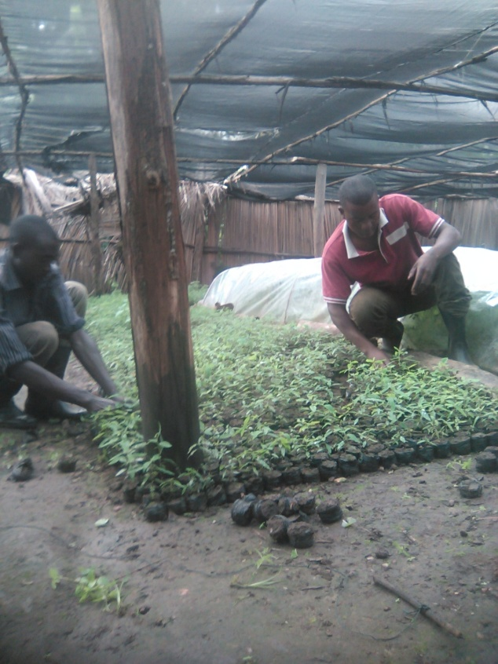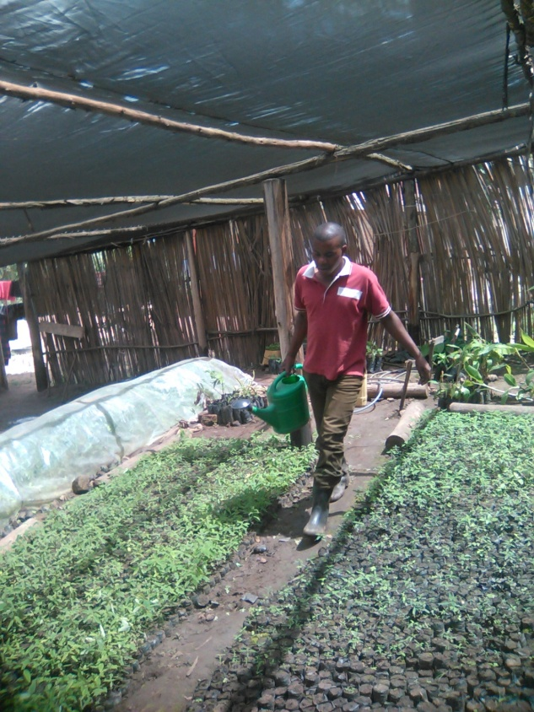
At the nursery I have also been involved in cutting of potato vines from mother garden and vine screen house which are given to farmers.
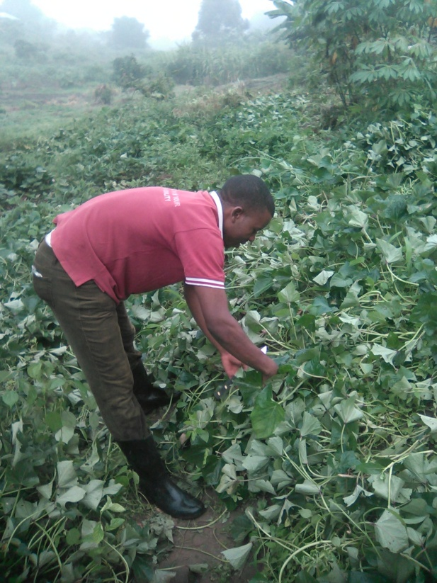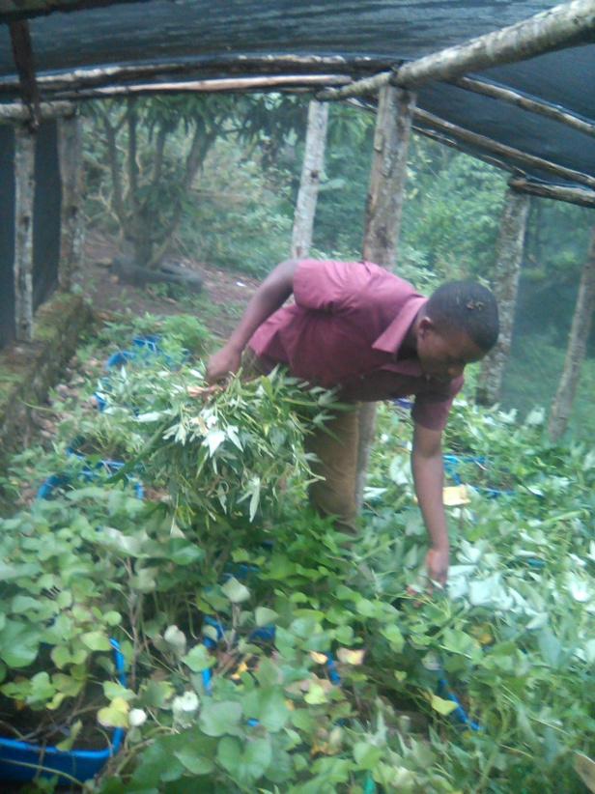

We have also raised eucalyptus seeds which will later be transferred to the nursery after germination and potted.
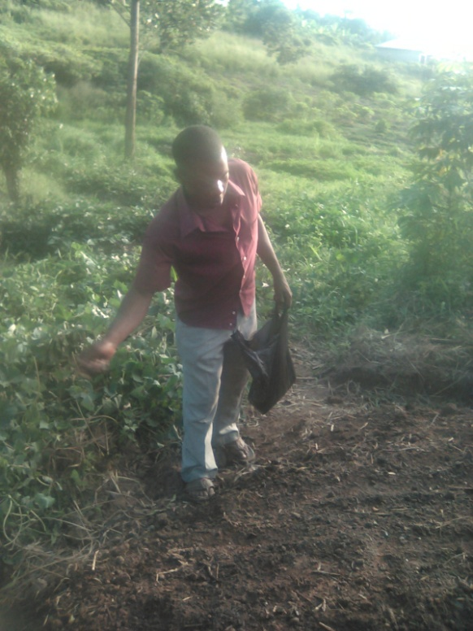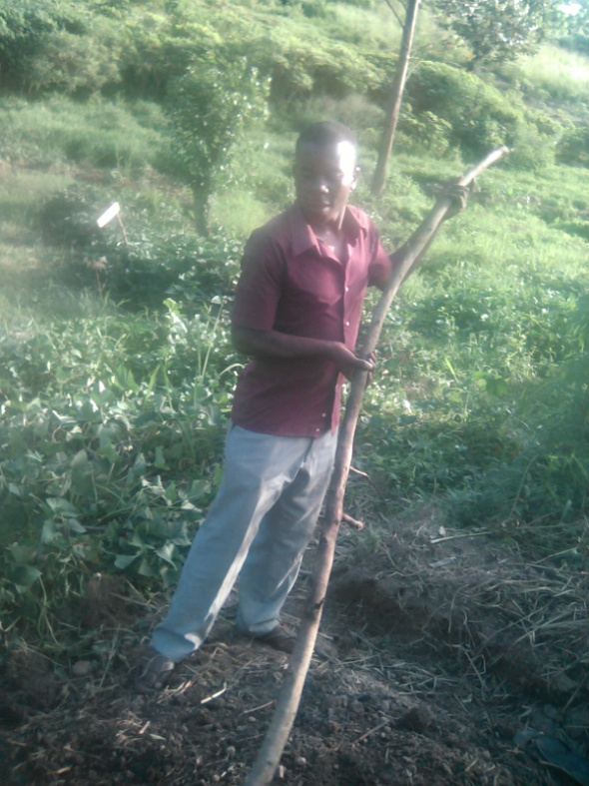
- Cassava project at kunywa farm
We had several activities at this farm which involved bush clearing, measuring spacing intervals (1mx1m) between plants, digging holes and planting cassava
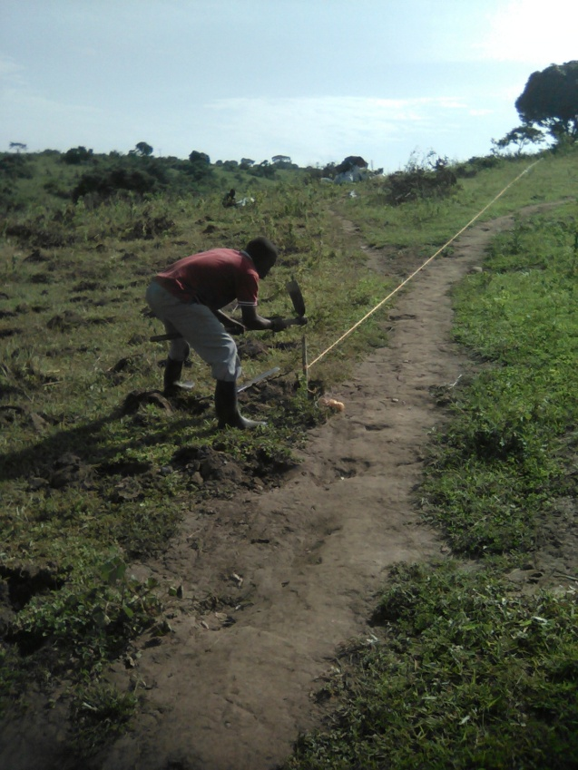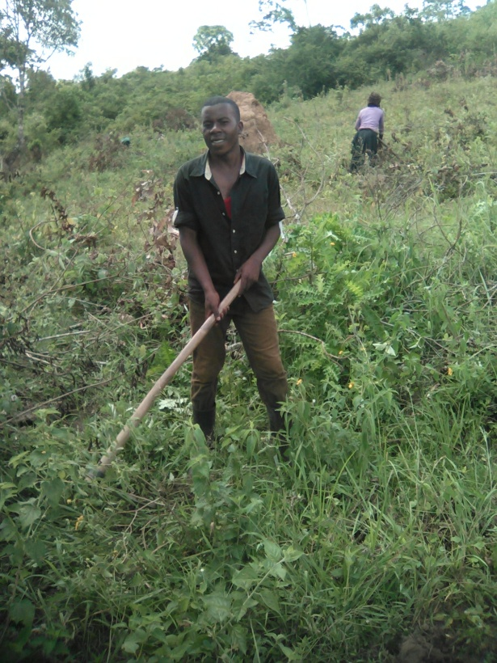
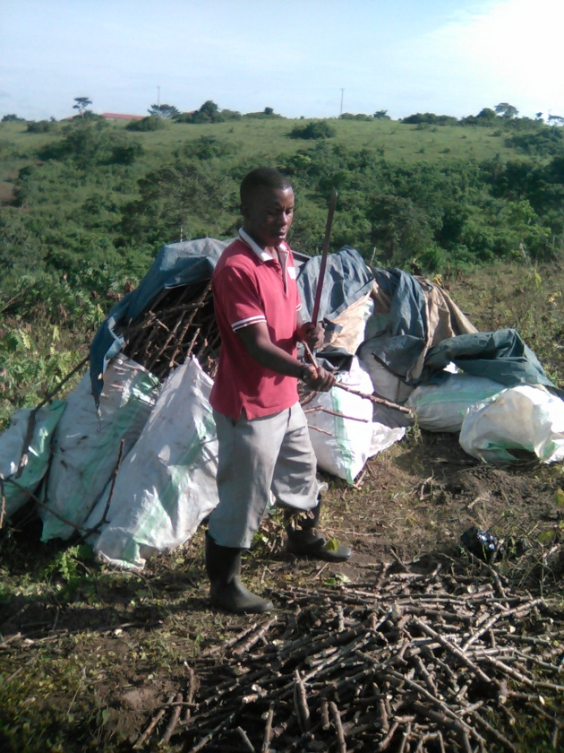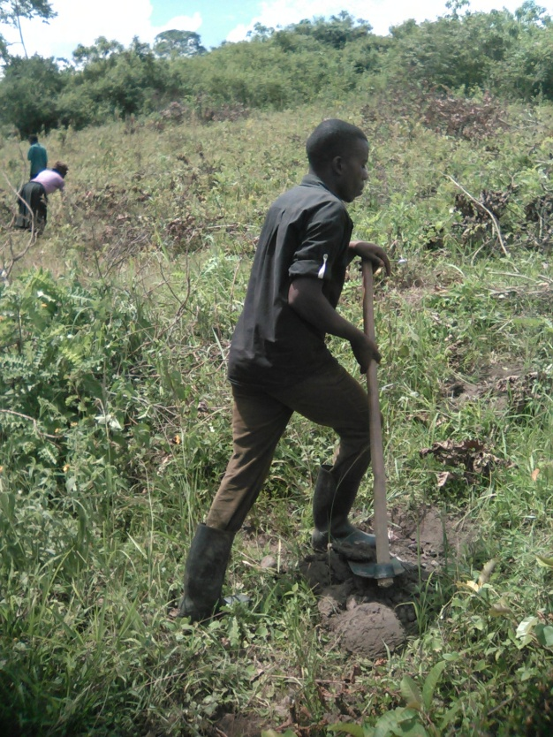
- Extension to farmers
We were able to visit a farmer at the district by names of Sister Godfrey from where we briefed her on sweet potato cultivation, orchard management, rearing of pigs using indigenous micro organisms and maize agronomy.
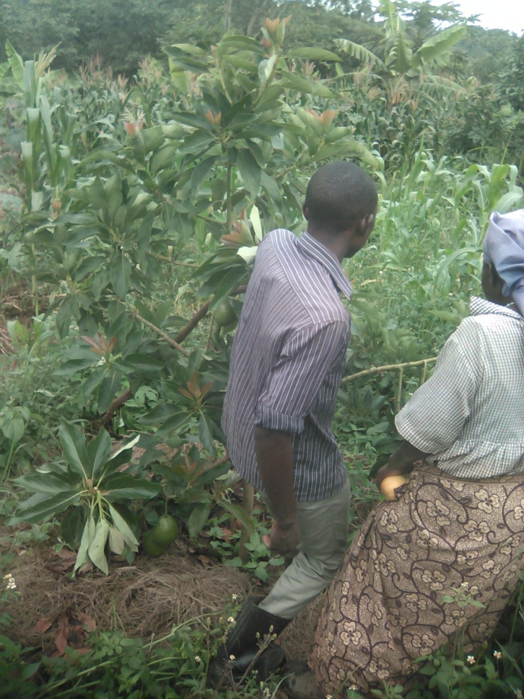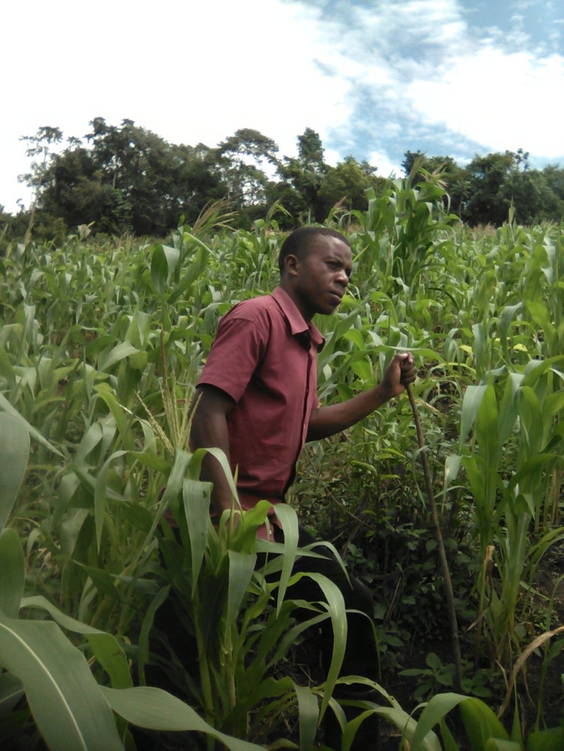
We also went to demonstrate to a farmer who had bought passion fruits from our nursery. We guided him on passion fruits management practices
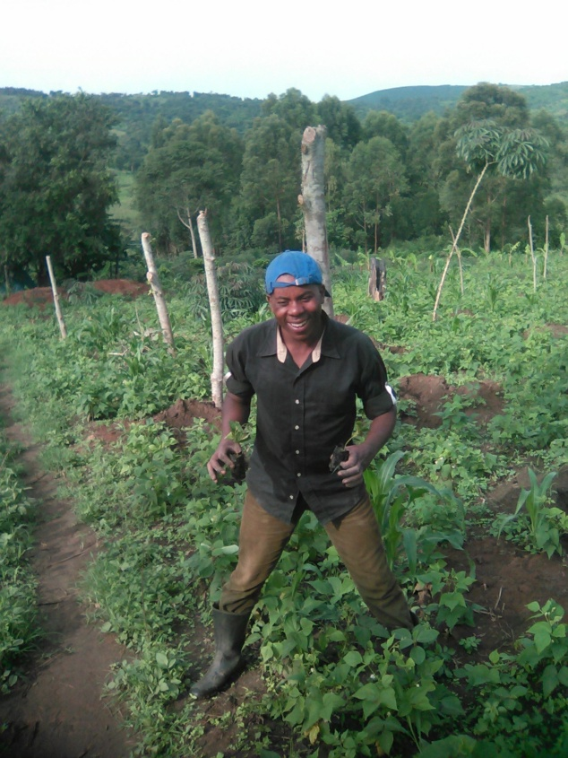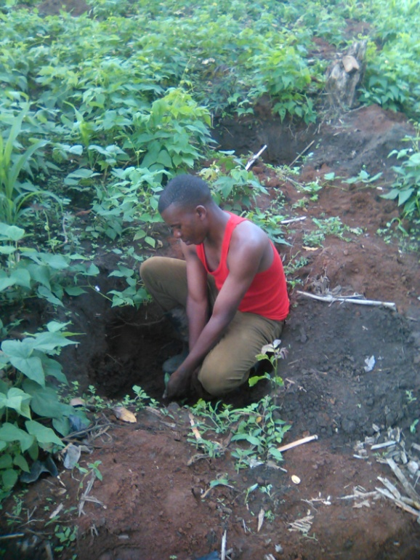
- Sweet potatoes demonstration at district demo farm
We were able to plant eight varieties of sweet potato vines at Mityana district demo farm

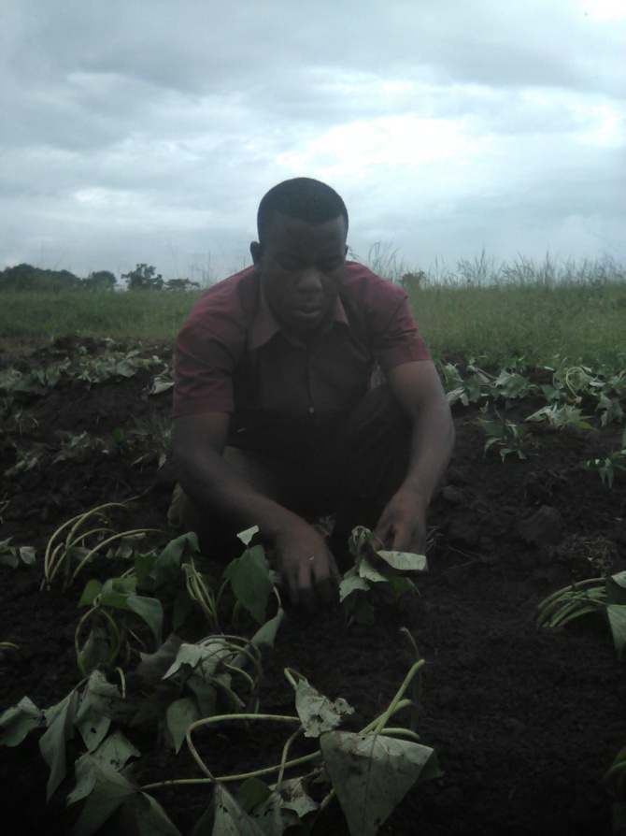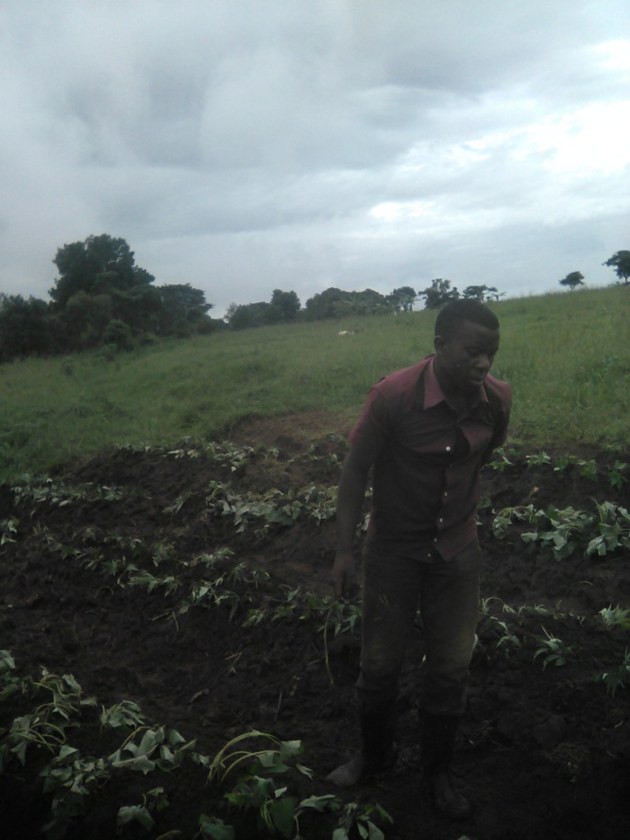
- Fencing at Namutumba farm
We have done part of fencing at Namutamba farm but this is still to be continued in June. This is
Challenges
We have been having s serious challenge of transport but now we are hoping for improvement since a motorcycle was brought on 30/05/3015.
More labour was lacking at kunywa cassava project
Recommendation
If possible, more clarification on use of 1MO’s (indigenous micro organisms) should be provided especially on application procedures in crops and pit latrines. Also storage conditions for IMO’S needs to stated clearly
Yours in service,
ROGERS MFITUMUKIZA
Internee Student 0787578139/0701518907
Cc: program officer CHAIN, Mr. Julius
Cc: nursery oprator, Mr. Charles

